7. ZIG-ZAG TRANSFORMER
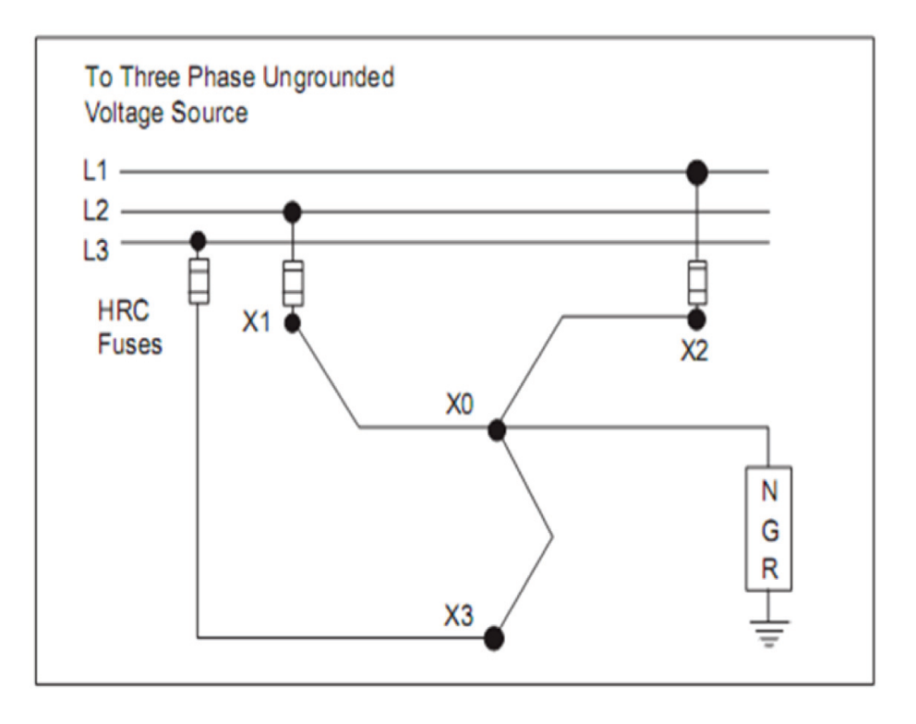
Fig: 7.1 Zig-Zag Transformer
In older 600V and lower systems, and in many existing volt and higher systems, the system neutral may not be available. To be able to ground these systems, grounding transformers can be used to create a neutral, which in turn can be connected to ground either directly. The Zigzag grounding transformer is a commonly used option Itis a three-phase dry-type, air- cooled auto-transformer with no secondary winding. Each phase has two identical windings, which are wound in opposite directions to give the high impedance to normal phase currents. The windings are connected in a Wye configuration. The neutral point is then neutral grounding resistor (NGR) to ground. When a ground fault occurs downstream of The Zig- zag transformer, ground fault current flows through the fault, back through grounded the NGR to the Zigzag where the current is divided equally in each leg of the
Zigzag. Since these three currents are all equal and in time phase with each other (zero sequence), and because of the special Zigzag winding connections, they see a very low impedance. This allows the ground fault current to flow back into the system. It can be seen that the ground fault current is only limited by the resistance of the ground fault, the NGR, and the small reactance of the Zigzag. The Zigzag should be connected to the system on the line side of the main breaker, as close as possible to the power transformer secondary terminals. When more than one power transformer is involved, one Zig- zag is required for each. Care should be taken not to have more than one Zigzag connected to the same section of the system at the same time. Short circuit protection should be provided on each of the three line connections of the Zigzag.

Features:

- Stainless steel grid or edge wound resistor banks(application dependent)
- Continuously rated Dry Type Transformer
- Mill Galvanized Type 3R enclosure with options for painted and stainless steel
- Extra heavy duty mounting channels for transformer
- Junction box / Terminal block for easy addition of protective relaying equipment Specification for Zigzag grounding transformer.

In the power supply to large industrial plants involving ACDC converters, power quality is a problem. The current on the AC side contains harmonics of the order k⋅n±1, where k is the number of pulses in the rectifying bridge and n=1, 2…Filters on the high voltage AC side are expensive and alternative solutions are often beneficial. When several AC-DC converter are installed in parallel, power transformers harmonic currents. In a particular industrial plant in 12-pulse AC-DC converters are installed in parallel with phase shifts -12º, -6º, 0º, +6º, and+12º, which results in an equivalent 60-pulse system .A zigzag coupling on the primary side and two secondary sides with 30 degrees internal phase shift supplying a 12-pulserectifying bridge is investigated in this paper.
The modelling of components in ATP is reported in the present paper the analysis is extended to the case of an arbitrary phase shift of <-60, 0> and <0, 60> degrees based on as a more general coupled RL-matrix formulation.

- Background and Case Model
Harmonics current and voltage have been existing since the beginning of the history of the alternating current (AC) power system. However, the type and quantity of the harmonic producing power electronics have rapidly increased today. Because the power electronics have advantages in terms of efficiency and controllability; therefore, it can be used at the different Chairul Gagarin Irianto, et al. 280 power levels ranging from a low voltage domestic tool to a high voltage converter. This means that the harmonics become a serious problem on the electric distribution system.
The important thing in the harmonics problem is that the spectrum of the distortion frequency will be depending on the type of non-linear loads. In general, the single-phase nonlinear loads which are supplied by the power distribution system are computers, servers, and fluorescent lamps. Frequency spectrum of the most dominant harmonics generated from this type of non-linear loads is the triplen harmonic, as shown in Table 2.

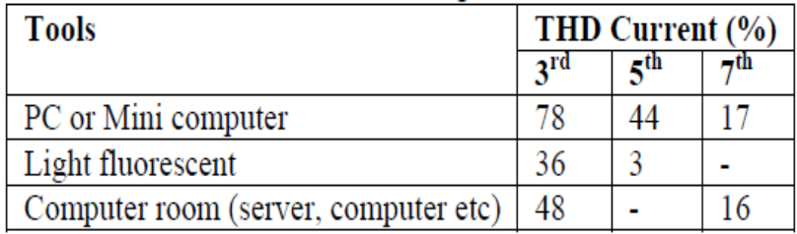

TableNo7.1: Nonlinear loads and generated harmonics

Triplen harmonic currents have become a very important issue in the modern power systems. The use of fluorescent lamps, which is getting bigger and widely dispersed, has caused a distortion to the sinusoidal voltage and current waveform. Furthermore, the non sinusoidal currents will interact with the impedance of the power system which in turn will increase the level of voltage distortion in the line and produce the resonance between the capacitor (if available) and supply impedance.

- DTz Transformer Model
The basic idea of the DTz transformer winding configuration is taken from the
transposition theory of the three-phase transmission line to overcome the asymmetric line inductance due to the magnetic geometric location in the transmission line. The idea was then applied for the DTz winding on the secondary side of transformer. By distributing the secondary phase winding among the three core legs symmetrically, it is expected that the transformer is able to inhibit the electromagnetic energy flow of harmonics and increase windings impedance. In this regard, the first principle of harmonic reduction is done by dividing the secondary phase winding N2 into three symmetrical parts ( 3) 2 N , and then put each part ( 3) 2 N of the windings on the transposed three core legs, finally they are connected
series, as shown in Figure 1.
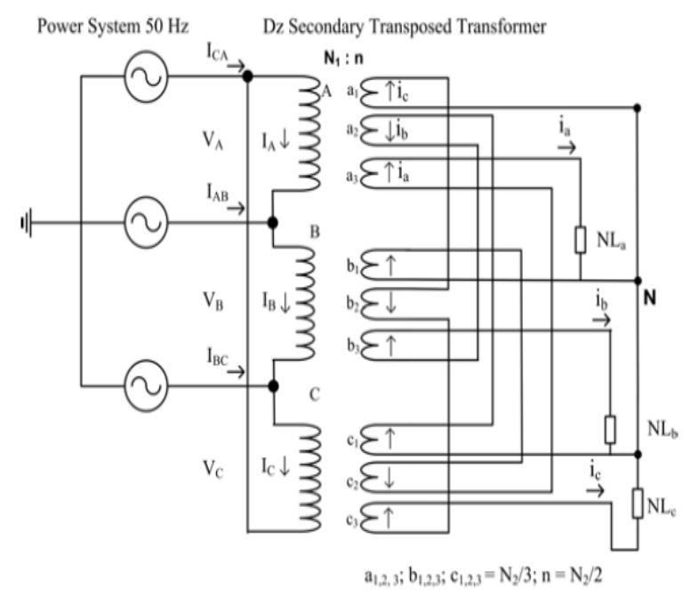
Figure7.2. Configuration of DTz windings Transformer
Figure 2 shows the proposed DTz transformer winding configuration to obtain mmf
induction phasors relationship between the primary and secondary. While Figure 3 shows the physical proposed DTz transformer when measurement are conducted in the laboratory.
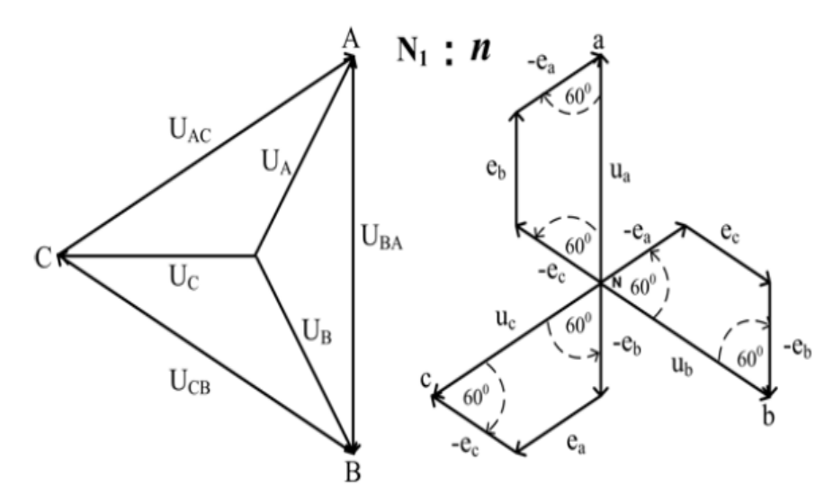
Figure 7.3 Primary and Secondary Phasor for Proposed DTz Transformer
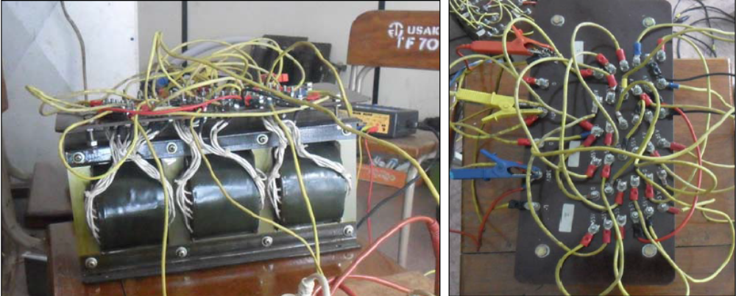
Figure 7.4. Proposed DTz Transformer on Laboratory Experiment
The phasors relationship of the primary and secondary voltage can be obtained by:
$\left[\begin{matrix}U_{AC} \\ U_{BA} \\ U_{CB}\end{matrix}\right]$=K₁$\left[\begin{matrix}u_{a} \\ u_{b} \\ u_{c}\end{matrix}\right]$k₁$\left[\begin{matrix}-1 & 1 & -1 \\ -1 & -1 & 1 \\ 1 & -1 & -1\end{matrix}\right]\left[\begin{matrix}e_{a} \\ e_{b} \\ e_{c}\end{matrix}\right]$₋₋₋₋₋₋₁
As shown in Figure 2, the vector diagram for each phase secondary voltage can be obtained by equation:
U_{a}=(-$e_{c}-e_{b}+e_{a}$)-------------2
For the balanced load condition,
$$i_{a}=i_{b}=i_{c}=i$$
thus, the mmf phase winding is, Chairul Gagarin Irianto, et al.
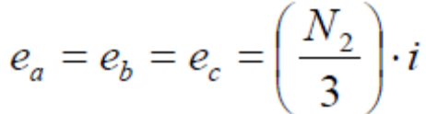
This value is equal to twice of the 1/3 mmf windings, namely:
----------3
From equation (3), it can be determined the ratio of DTz secondary winding transformer which is k (N n) 1 1 = , where ( 2) 2 n= N . As reviewed, the DTz transformer is loaded by non-linear loads as shown in Figure 4.1.1
The diagram shows the first principle of the harmonic reduction, which is the reduction of mmf triple harmonic on the same core legs in the phase windings. In other words, the resultant of the mmf induction of the triplen harmonic currents from the secondary windings is getting smaller.

Figure 4(a) shows the relationship of the mmf vector of the secondary phase winding current which is formed by a zigzag winding connection. The harmonic currents in the zigzag winding, which is minimized in the delta winding, are:
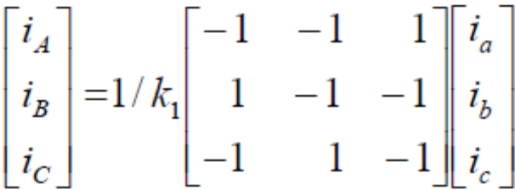-----------4

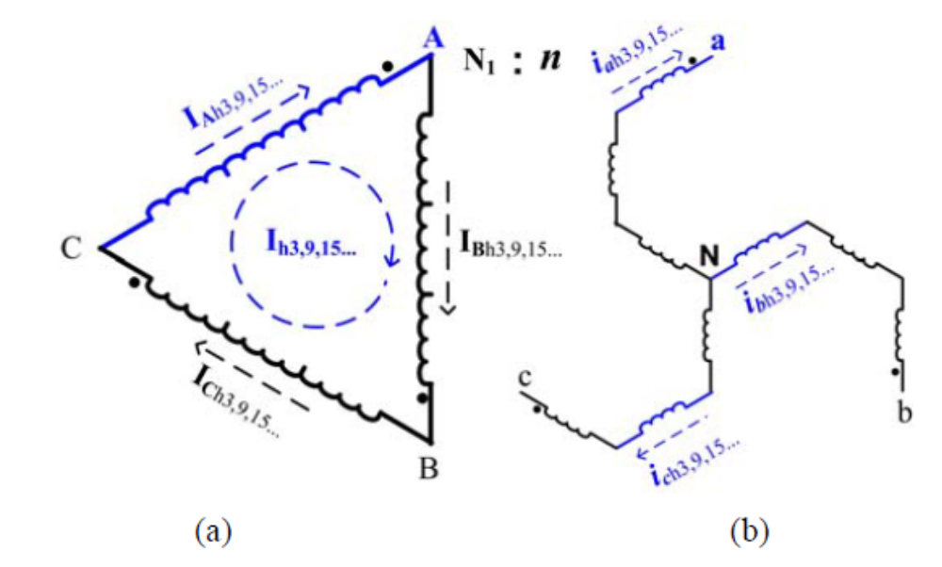
Figure7.5. (a) Circulation of the triplen harmonic currents in the primary delta winding,
(b) Reduction of the triplen harmonic currents at the secondary winding.

Figure 4(b) shows the polarity of current relationship in the secondary winding. The phase current -a, a i is the sum of the fundamental currents components, a1 i and the odd-order of the harmonic currents, ah i . If the effective current, a rms a I =i then,
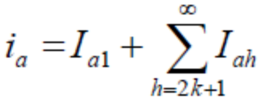--------------------------5
Where k = 1, 2, 3,.. is the integer multiplication of the fundamental frequency. If it is
assumed that the power supply is a three-phase source, the third harmonic components and its triplen will be in phase. This condition can be stated as,
---------6
Figure 4 (a) shows the second principle that is as an insulator in which connecting the
primary winding 1 N in the delta configuration. This condition causes the flow of harmonic currents is insulated or forced to circulate only in the primary delta winding so it will not flow and distort the sinusoidal waveform of the current and voltage at the power supply side. The formula shows that the magnitude of the triplen frequency decreases to one third of the harmonic currents in the primary side when using balanced loads. For example, the current circulation in A-phase windings on the primary A-leg core;

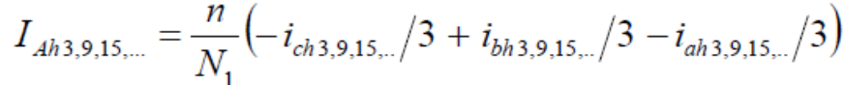-------------7

This yields,

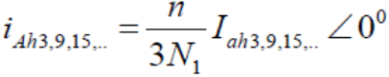-----------------8

Equation (8) describes the remaining harmonic current which is induced to the primary delta windings through the core is becoming smaller. This will therefore minimize the loss of the harmonic current circulation.
Besides having capabilities to reduce the triplen harmonics by cancelling phase polarity and circulation, the additional advantage of the DTz winding transformer is much more efficient as it can reduce the transformer loss. This advantage is obtained by increasing the resistive impedance of the transformer windings.
Figure 4.1.1 and equation (9) inform that to produce an effective output voltage 2 V , the need of the mmf induction of the secondary DTz transformer is larger than that of the Dy transformer and conventional secondary Dz [13]. The mmf induction ratio in secondary winding of Dy, Dz and DTz transformer is 1 : 1.33 : 1.55, as shown in Figure 5.c1, 5.c2 and 5.c3, respectively.
In other words, to produce an effective output voltage 2 V the DTz transformer needs a mmf of 1.55 times much bigger than that of Dy transformer. With the same condition, DTz requires about 1.16 times much bigger than that of the conventional transformers Dz. When mmf induction is high, the inductive impedance value becomes higher as well. As the result, the electromagnetic energy of the triplen harmonics can be resisted to enter the supply system. In addition, based on Ohm's law,
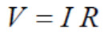--------------9

Where: V is the effective output voltage 2 V [Volt]; I is current [Ampere], and R is the resistive impedance of windings [Ohm].
And, based on the equation of power loss of transformer windings :
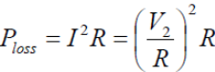-------------10 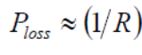---------------------11
Where loss P is the power loss in the transformer windings (Watt).
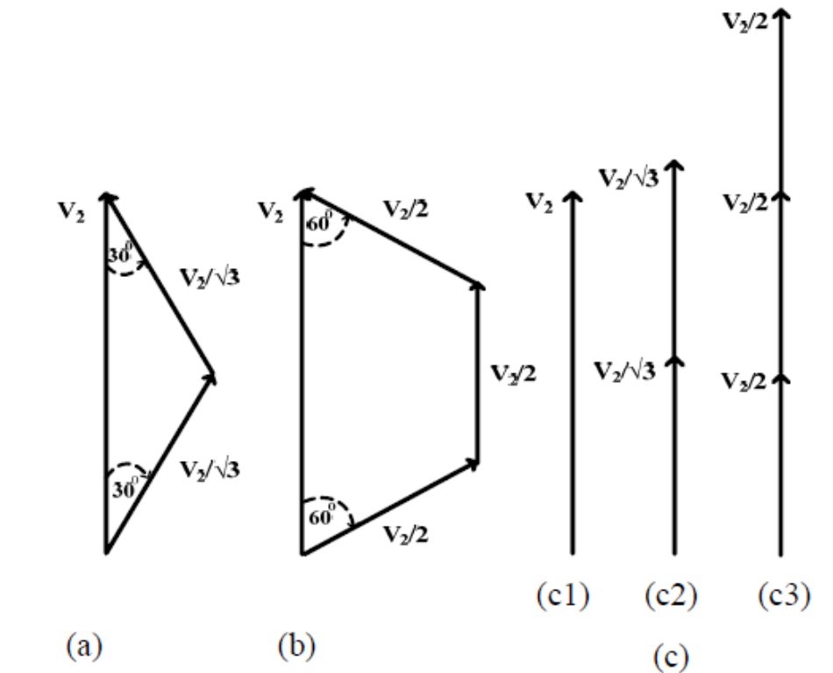
Fig 7.6 Secondary side of voltage phasor 2 V (a). Dz transformer, (b). DTz transformer; and (c) The resultant of voltage vector 2 V on transformer (c1) Dy, (c2) Dz and (c3) DTz.
This shows that the impedance values of DTz windings is bigger than that of other transformers as shown in Figure 6. As the power and resistive impedance is linear, thus, a change in resistive impedance has a proportional relation to the power loss. This means, for the same input of the power capacity, the efficiency of the DTz transformer will be higher.
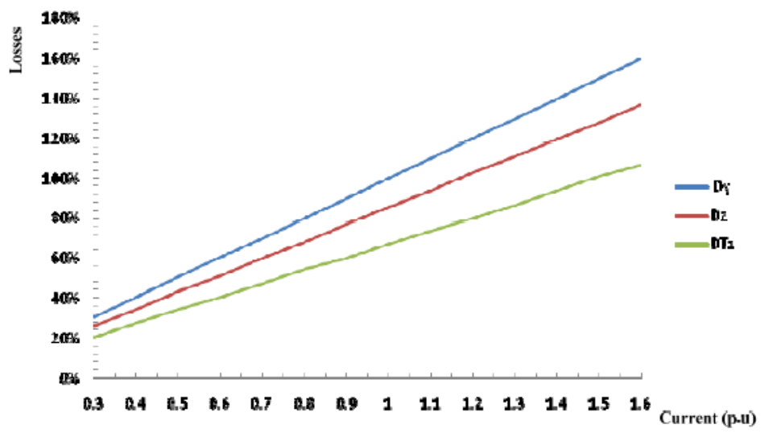
Figure7.7. The ratio of output currents and power loss of the Dy, DZ and
DTz transformer windings.

